Walton Family
Whole Health & Fitness
Summer Camp
  - Parent Handbook

Welcome to Summer Camp!

Welcome to the Walton Family Whole Health & Fitness Kids Camp! We are thrilled to have you join us for a fun-filled and enriching experience focused on promoting health, wellness, and active lifestyles for our young campers. Get ready for a summer of exciting activities, learning, and growth in a supportive and nurturing environment. Let's make this a memorable and rewarding journey!

Walton Family Whole Health & Fitness Summer Camp is a licensed program for members who are entering first grade through age 12. We’re excited to be one of the first facilities to integrate the Whole Health concepts into our programs at Walton Family Whole Health & Fitness. Kids will explore the various parts of Whole Health each week through fun activities, games, crafts, and special events that teach skills to improve health and well-being!

This parent handbook is provided to every parent during the registration process. Please read the entire handbook carefully. You will be asked to verify by signature that you received the handbook and that you understand all policies. It is important that each child also understands and follows all rules, policies, and procedures. This handbook is designed for your benefit and to provide you and your child a fun, stress free, and enriching summer.

Camp Dates
Week 1: June 10-14 Week 5: July 15-19
Week 1: June 17-21 Week 6: July 22-26
Week 3: June 24-28 Week 7: July 29-Aug 2
Week 4: July 8-12 Week 8: Aug 5-9

*Summer Camp will NOT be held the week of July 1-5

Drop Off and Pickup Policy

Camp is available daily from 7:30 a.m. to 5:30 p.m. Valet morning drop off is from 7:30-8:15 a.m. and valet pick-up is from 5:00-5:30 p.m. Please DO NOT arrive any earlier than 5:00 p.m. for valet pick up. Drop off and pick up location is in the drop off lanes in the front of the Fitness Facility. A map will be available on the Walton Family Whole Health & Fitness Summer Camp webpage. A Staff Member will be outside to help your child in/out of the vehicle and ask you to sign in/out. If a child needs to be dropped off at or after 8:15 a.m., you must escort your child into Walton Family Whole Health & Fitness to the appropriate group/area and sign them in. All children need to be picked up promptly before 5:30 p.m.; after this time, there is a $1.00 late fee per minute/child that will be added to your profile and must be paid before the child can attend the next day. After three times in violation of this policy, parents will be asked to find alternative childcare and a refund will not be issued. For safety reasons, our staff will ask for a valid cellphone number during drop off and pick up. Children will only be released to those on their approved pickup list. Any changes to the approved pickup list must be made in writing or by email to the Program Director.

Snack and Lunch Policy

A morning and afternoon snack is provided for each child every day. We also encourage children to drink water throughout the day, please provide a reusable water bottle. Parents will be required to provide an appropriate lunch for their children each day. If a child arrives without a lunch, parents will be notified immediately. Lunch is not provided or sold by Walton Family Whole Health & Fitness. Please let us know if your child has any dietary restrictions or food allergies. Please do not send any food that needs to be refrigerated or warmed in a microwave. Children with food allergies or food restrictions will also be required to bring their own snacks. Fast food, soda, and sweets are not permitted. Please do not send your child in with food or drinks for breakfast. We will ask them to throw it away. Children are not permitted to share their lunch or snacks with anyone else.

Kids Camp Policy: Nut-Free Zone
For the safety and well-being of all campers, Walton Family Whole Health & Fitness Kids Camp is a nut-free zone. Please refrain from bringing any nut products or foods containing nuts to camp, including peanuts and tree nuts, to prevent allergic reactions among our campers. We appreciate your cooperation in creating a safe and inclusive environment for all children attending camp.

Administration

As a licensed out of school program, we must inform you that children may be subject to interviews by licensing staff, child maltreatment investigators and/or law enforcement officials for the purpose of determining licensing compliance or for investigative purposes. Child interviews do not require parental notice or consent. All paperwork is to be available for licensing to review upon request. We will perform daily backpack/bag checks as required by Minimum Licensing Requirements.

Emergency Transportation Policy

In the event of an emergency, children may be transported by emergency vehicle for immediate attention, and the Parent/Guardian will be immediately notified.

Summer Camp Staff & Child Groups

The Director will be placing children in different groups based on age and/or school grade. Because of strict licensing ratio requirements, children will not change groups based on summer birthdays. It is important that children remain in the group assigned unless the summer program director changes the group. We will change a child’s group at our discretion for: special needs, behavior concerns, and/or personality conflicts. Changing a child’s group allows us to provide your child with the best and appropriate care. Please ask your child what group they are in. This will help us know where to locate your child’s group if they are being dropped off late or picked up early. Please also make sure to notify the Director of any changes in emergency information (phone numbers, email addresses, emergency contacts, additional pickup, etc.)

Example Daily Activity Schedule: Adventure week
7:30 am - 8:15 am: Drop-off and Welcome Activities (YAC 1)
- Campers arrive, check-in, and participate in morning icebreakers and team-building activities.
8:15 am - 9:00 am: Morning Energizer (Wallyball court or Basketball Court)
- Engaging team building activities to get campers moving and energized for the day ahead.
9:15 am - 10:15 am: Adventure Challenge (Tennis Court or Turf Field)
Obstacle course challenge, or scavenger hunt.
10:30 am - 11:00 am: Snack Break and Hydration (Teaching Kitchen)
Campers enjoy a nutritious snack and hydrate before the next activity.
11:15 am - 12:15 pm: Creative Arts and Crafts (Outdoor Meditation Garden)
- Campers engage in arts and crafts activities, such as nature-inspired art projects or DIY crafts.
12:30 pm - 1:30 pm: Lunch and Rest (YAC 1)
- Campers have lunch, relax, and recharge for the afternoon activities.
1:45 pm – 2:45 pm: Sports and Team (Indoor Pool)
- Campers participate in various water sport activities, team games, and friendly competitions.
3:00 pm - 3:30 pm: Healthy Snack Break (Aquatics node)
- Campers refuel with a healthy snack to keep their energy levels up.
3:30 pm - 4:30 pm: Science and Nature (YAC Studio 1)
- Campers engage in hands-on science experiments, nature studies, or environmental education activities.
4:30 pm - 5:00 pm: Daily Reflection and Wrap (YAC Studio 3)
- Campers reflect on the day's activities, share highlights, and prepare for pick-up.
5:00 pm: Pick-up and End of Day
- Parents/guardians pick up campers.
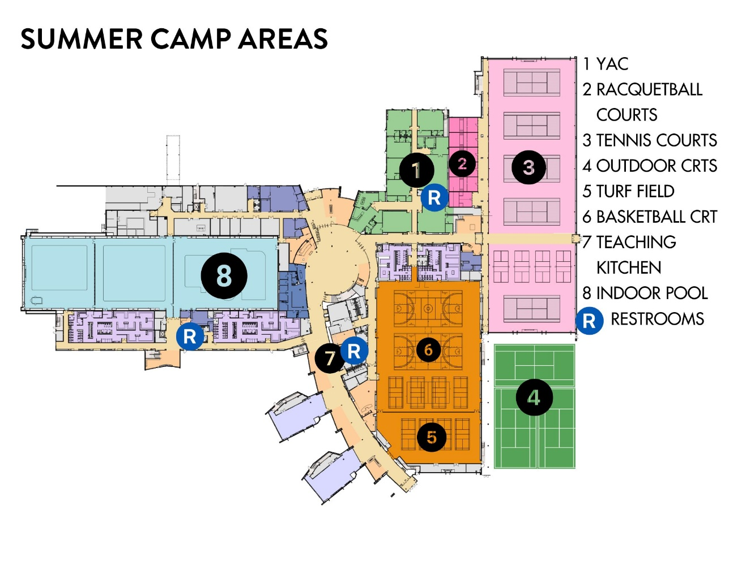

Pictures

Throughout summer camp, we take pictures of kids enjoying different activities. These pictures will be used on marketing material, such as flyers, website, and social media to promote our programs. Please indicate on the registration form whether your child may be photographed or not. We take this seriously, because we understand that sometimes it’s not in the child’s best interest to be photographed. We are very diligent in ensuring children are not in pictures if that is the parent’s request. Additionally, if you take photos of your child during the summer program and there are other children in the photo, please ensure that their faces are not visible or that these photos are NOT shared on social media. In doing so, you will be in violation of the childcare licensing policies.

Additional Information

The only items that are allowed in summer care are a packed lunch, water bottle, swimming suit, towel, sunscreen, and an extra change of clothes each day. Personal items such as toys, blankets, stuffed animals, electronics, or cell phones are not allowed. If these items are brought, they will be sent home with you. Children need to wear appropriate clothing to play and have fun. Tennis shoes are required. Water shoes can be brought and worn to the pool, but tennis shoes will be put back on after swim time.

SUMMER CAMP CODE OF CONDUCT
We want our children to have an enjoyable, rewarding, and safe experience. To help accomplish that, we require all children to comply with the following policy. The children are responsible for knowing and abiding by the rules of our Out of School Program. Parents are responsible for helping their children understand the rules.

Manners:
All children need to follow basic courtesies with counselors and one another. This includes table manners, politeness, and taking care of equipment and facilities. Please make sure your child understands the importance of following rules and directions given by counselors.
Behavior:
We view discipline not as a punishment, but as a way of teaching children what is acceptable behavior.
Prohibited conduct may include, but is not limited to:
- Disrespect for counselors and other children
- Disruptive behavior or inappropriate language
- Stealing property
- Inappropriate public displays of affection
- Bullying
- Any conduct prohibited by the Non-Violence Policy is included below.
Should discipline be necessary, the following 5 measures may be taken to address inappropriate behavior. Depending on the severity of the conduct and whether it is repeated, any of the measures below may be taken immediately.

- Verbal Warning: The staff will provide the child with a clear verbal warning, explaining the inappropriate behavior and the expected behavior in the camp setting.
- Time-Out: If the behavior persists, the child will be given a time-out to allow them to calm down and reflect on their actions, with staff supervision to ensure safety and compliance.
- Parent/Guardian Notification: If the behavior continues after the time-out, the parent or guardian will be notified of the situation and asked to discuss the behavior with their child.
- Performance Expectations: A performance behavior plan may be emailed and implemented, outlining specific expectations and consequences for the child's behavior moving forward, with input from the parent or guardian.
- Escalation to Camp Director: In cases of repeated or severe inappropriate behavior, the issue will be escalated to the Camp Director for further intervention and potential disciplinary action, such as suspension from the program.

Non-Violence Policy
Prohibited Conduct
The following conduct is prohibited and may result in any of the above corrective measures, including suspension or permanent removal from camp.
- Any form of violence or threat of violence in or affecting the care, other children, WFWH&F staff and members, or anyone on WFWH&F premises. This includes, but is not limited to, any conduct or communication (whether direct or indirect) which:
  - harms, damages, injures, harasses, intimidates, bullies, threatens, stalks, taunts, forces, coerces, restrains or confines another person;
  - reasonably causes another person to fear for his/her health or safety; or
  - intentionally harms or damages property; or
  - causes intentional harm to oneself.
Such conduct may be prohibited even when it occurs off our property, including postings on the internet or other electronic communications.
- Possession of weapons, including, but not limited to, firearms, knives, and explosives. Any object that may be used to harm another, or which reasonably causes another person to fear for his/her safety, may be considered a weapon. This includes objects that may only appear to be dangerous, such as toy guns or knives.
- Any other conduct which may endanger the health and safety of children, staff and members, or anyone on Walton Family Whole Health & Fitness premises.
Reports of violence or threats of violence will be investigated, and law enforcement may be contacted, when appropriate.

Health and Safety Requirements
We are required to obtain immunization records, under the direction of DHS. Even if the child is registered, admission will not be allowed without proper documentation.

Please understand these policies are in place to protect your child, rather than to create a hardship on anyone. A child sent home with any illness will not be able to return to the summer program until they are symptom free for 24 hours. This means that if a child is sent home during the day, he/she may not return the next morning, but must wait until the 24-hour period has passed or has a doctor’s note stating that the child may return to the summer program and is not contagious.

Medication: If a child needs to take medication, the parent must come and give the child the medicine needed. This is for all types of medicine: prescription and over the counter.

Medical concerns: It is important for parents to bring to the Director’s attention any medical problems or allergies a child may have. We may consult with the counselor and modify activities, if necessary.

Illness Policy: Parents agree to keep their child/children at home or seek alternate care arrangements for the following conditions:
- Pain: any complaints of unexplained or undiagnosed pain.
- Fever: A child cannot attend the summer program while taking Tylenol or another fever-reducing medication to maintain a normal temperature. A child will be sent home if the temperature is at or above 100 degrees auxiliary. If other symptoms exist, a child may be sent home with a lower temperature stated above.
- Diarrhea: Three or more watery stools in a 24-hour period
- Vomiting: Vomiting on two or more occasions within the past 24-hour period.
- Pink Eye: Pink or red eye(s) which may be swollen with white or yellow discharge; child may return when on antibiotics for 24 hours.
- Difficult or Rapid Breathing
- Severe Coughing
- Skin Conditions: which have not been diagnosed as non-contagious by a physician; may include ring worm, impetigo.
Parents or guardians will be notified immediately if Summer Camp staff observe symptoms of illness in your child. You or someone designated on the pick-up form is required to pick up your child as soon as possible.
Contagious Illnesses:
- Parents must notify the Director within 24 hours of a diagnosis of a serious illness or contagious disease including pink eye, head lice, strep throat, influenza, mono, common cold, ring worm, etc.
To help prevent these illnesses from spreading, please educate your child on good personal hygiene.
- Wash your hands with soap and water.
- Cover your mouth with your arm when coughing or sneezing.
- Do not share food or drinks.
- Do not share hairbrushes, combs, hats, towels, or other hair accessories.

Payment, Cancellation & Refund Policy

Payment
Summer Camp fees are $175 per week, per child. This includes all programming, arts & crafts, and two daily snacks. Payment is due at the time of registration.

Payments can only be made by Credit Card. If the proper cancellation process is not followed (see below), you must pay for unattended time and your child will not be permitted to return to the summer camp program until fees are paid.

Cancellations
All cancellations must be turned in using the cancellation form via paper copy or email to tony.buagas@walmart.com. If your child will not attend a week that he/she is signed up for, you need to cancel that week, a full week in advance. Cancellations cannot be made over the phone or via a counselor. Cancellations made in time will result in a full refund of weekly fees of $175.

Example of Cancellation:
Your child is signed up for the week of June 10-14, but now your plans have changed; you must cancel by Friday, May 31st, for a full refund. In case of an emergency, please contact the Camp Director.

Cancellation Dates for Full Refund
Week 1: June 10-14 needs to be cancelled by 5/31
Week 2: June 17-21 needs to be cancelled by 6/7
Week 3: June 24-28 needs to be cancelled by 6/14
Week 4: July 8-12 needs to be cancelled by 6/28
Week 5: July 15-19 needs to be cancelled by 7/5
Week 6: July 22-26 needs to be cancelled by 7/12
Week 7: July 29-August 2 needs to be cancelled by 7/19
Week 8: August 5-9 needs to be cancelled by 7/26

Refunds
Should your plans change during the summer, complete the weekly cancellation form, and submit by the specified date for the week(s) you plan to cancel. Cancellations following this process will be eligible for full refunds of weekly fees.

Weekly Cancellations Form
To receive a refund, forms must be received 1 full week prior to the week being cancelled.
Name of child(ren): __________________________________________________
Circle or highlight the weeks you wish to cancel:
Cancellations
Week 1: June 10-14
Week 2: June 17-21
Week 3: June 24-28
Week 4: July 8-12
Week 5: July 15-19
Week 6: July 22-26
Week 7: July 29-Aug 2
Week 8: Aug 5-9
Comments: _______________________________________________________________________________________________________________________________________________________________________________________________________________________________________________________________ Parent Signature: _________________________________ Date: ___________________________
Parent Phone Number: _____________________________________________________________

